**ASSIGNMENT32**

**CLL788**

**Submitted by:**

**Mohd Zaki**

**2019CEZ8233**

**Department of Civil Engineering**

Table of Contents

Solution to Question 1 2

1) Visualizing training data (Data1.xlsx) 2

Solution to Question 2 2

2.) Training data with decision boundary obtained by running vanilla version of SVM 2

Solution to Question 3 3

3.) Modified Optimization Problem 3

Table of Figures

**Figure 1 – Visualizing training dataset** 2

**Figure 2 - SVM Result** 2

**Figure 3a - Comparing effect of C** 3

**Figure 3b - Comparing effect of C≤ 1** 3

# Solution to Question 1

## 1) Visualizing training data (Data1.xlsx)

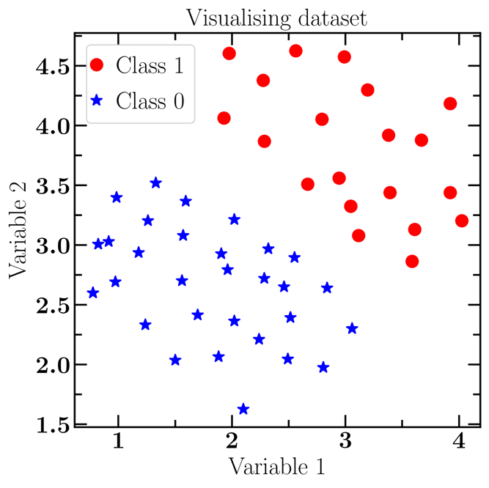

**Figure 1 – Visualizing training dataset**

# Solution to Question 2

## 2.) Training data with decision boundary obtained by running vanilla version of SVM

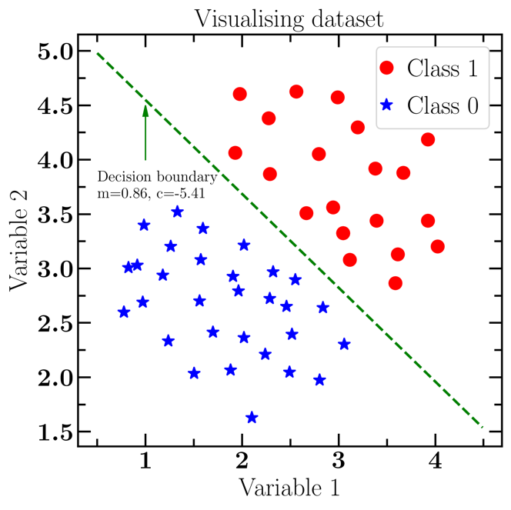

**Figure 2 - SVM Result**

# Solution to Question 3

## 3.) Modified Optimization Problem

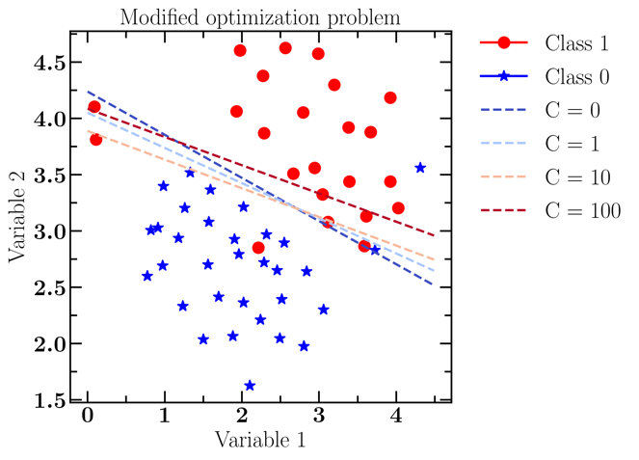

**Figure 3a - Comparing effect of C**

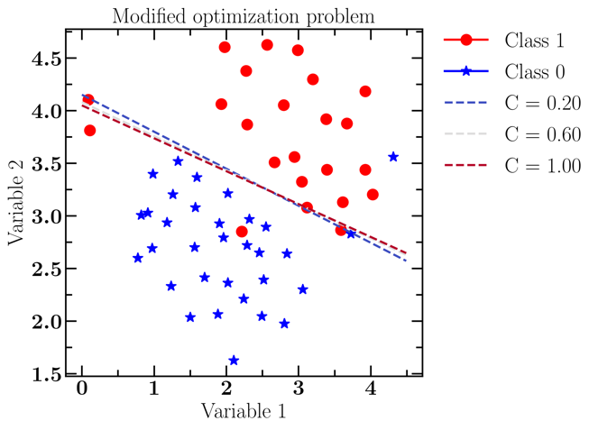

**Figure 3b - Comparing effect of C ≤ 1**

# Solution to Question 4

## 4.) Naïve Bayes Classification

Pre-requisites:

|  |  |
| --- | --- |
| Probability | Value |
| P(stolen = yes) | 0.5 |
| P(stolen = no) | 0.5 |
| P(red | stolen = yes) | 0.6 |
| P(red | stolen = no) | 0.4 |
| P(SUV | stolen = yes) | 0.2 |
| P(SUV | stolen = no) | 0.6 |
| P(domestic | stolen = yes) | 0.4 |
| P(domestic | stolen = no) | 0.6 |

**Hence,**

**P(stolen = yes | (Color = red, Type = SUV, Origin = Domestic)**

**= P(red | stolen=yes) x P(SUV | stolen=yes) x P(domestic | stolen=yes) x P(stolen=yes)**

**= $\frac{3}{5}×\frac{1}{5}×\frac{2}{5}×\frac{1}{2}$**

**= 0.6 x 0.2 x 0.4 x 0.5**

**= 0.024**

**P(stolen = no | (Color = red, Type = SUV, Origin = Domestic)**

**= P(red | stolen=no) x P(SUV | stolen=no) x P(domestic | stolen=no) x P(stolen=no)**

**= $\frac{2}{5}×\frac{3}{5}×\frac{3}{5}×\frac{1}{2}$**

**= 0.4 x 0.6 x 0.6 x 0.5**

**= 0.072**

By normalizing the above quantities to sum to one,

The conditional probability that the target value is no, given the observed attribute values =

$$\frac{0.072}{0.072 +0.024} =0.75$$

The conditional probability that the target value is yes, given the observed attribute values =

$$\frac{0.024}{0.072 +0.024} =0.25$$

Since, conditional probability of target value as No > conditional probability of target value as Yes

Thus, our example gets classified as ’NO’